AWS-cloud-installation challenges

Launch one EC2 instance using Amazon Linux 2.
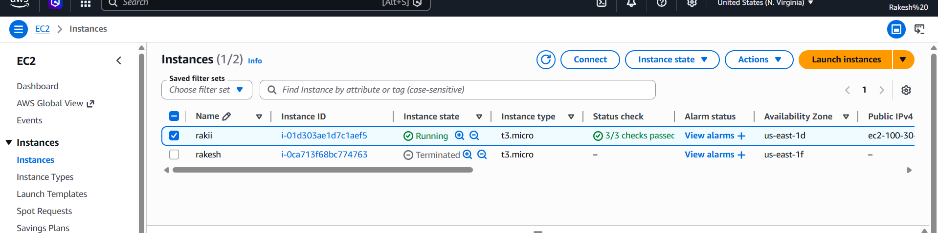

Install Docker.
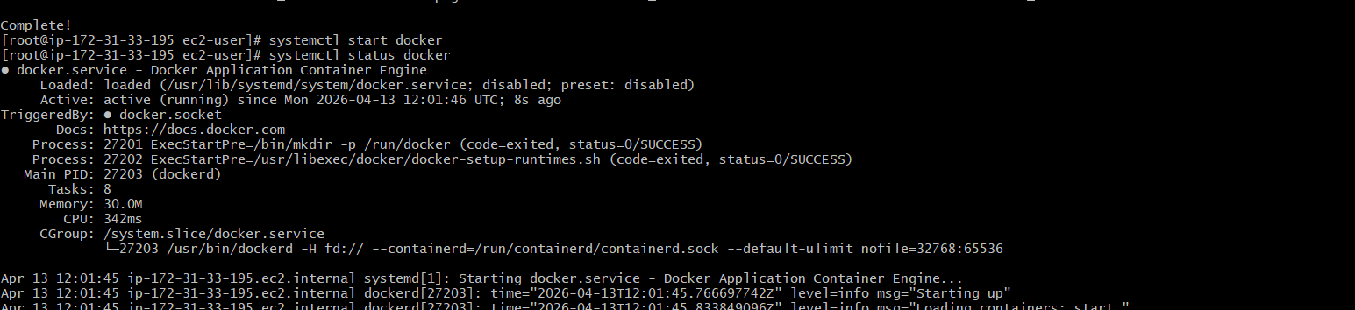
Install Jenkins.
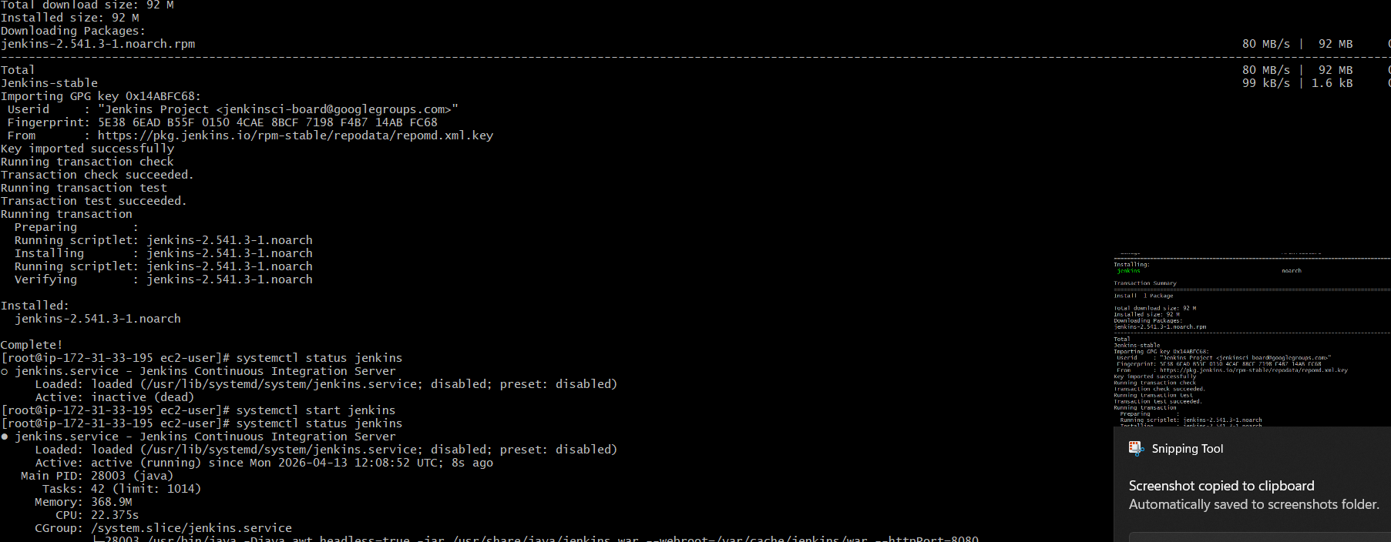
Install Apache. (httpd)
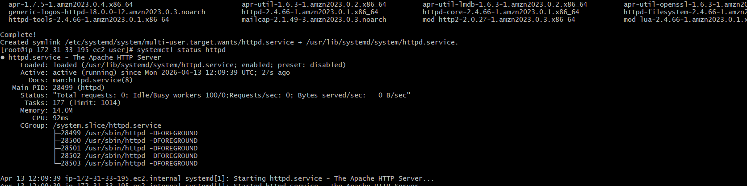

Install Nginx.
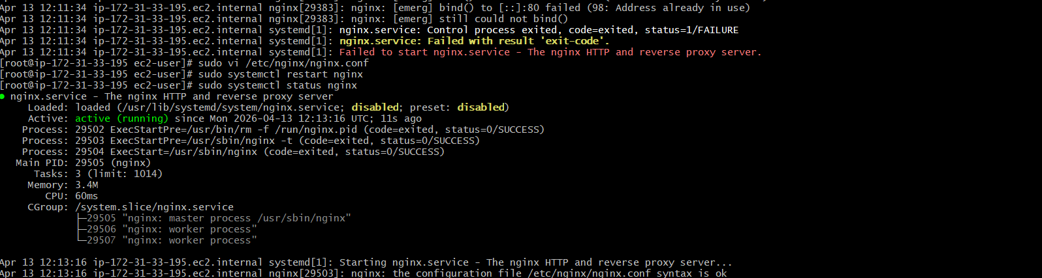
Install Apache Tomcat.
